TASK 1 Understanding the Problem and Identifying the Data

The milk payment problem requires the program to accept daily entries from farmers and compute a fair payment based on quality and quantity of milk supplied, then accumulate this into a ten-day total.

Inputs:
- Farmer ID — a text value (string) used only to identify the farmer; it is never used in calculations.
- Litres — a fractional (float) value representing the quantity of milk supplied in one shift. It can have decimal values (e.g., 8.5 litres).
- Fat % — a fractional (float) value representing the fat content of the milk, typically ranging between 2.0% and 7.0%.
- SNF % (Solids-Not-Fat) — a fractional (float) value representing the non-fat solid content, typically ranging between 8.0% and 9.5%.
- Shift — a text value (string) indicating "morning" or "evening", used only for record-keeping, not calculation.
Outputs:
- Rate per litre — a fractional (float) value computed from the fat and SNF readings, rounded to 2 decimal places (since it represents currency).
- Amount — a fractional (float) value equal to litres multiplied by the rate per litre, rounded to 2 decimal places.
- Ten-day total — a fractional (float or Decimal) value that is the sum of all amounts paid to a farmer over ten days.
Constants (values that never change during a run):
- BASE_RATE (Rs 30.00 per litre at 3.5% fat and 8.5% SNF) — fixed by the co-operative for a season.
- FAT_STEP_VALUE (Rs 0.40 per 0.1% fat above/below standard) — fixed rate card value.
- SNF_STEP_VALUE (Rs 0.30 per 0.1% SNF above/below standard) — fixed rate card value.
These are named constants because, although they may change between seasons, they remain fixed throughout a single run of the program (one day's processing), so hardcoding them as variables inside loops would be both wasteful and error-prone.
Classification of data types:
- Whole numbers (int): number of fat/SNF steps (since steps are counted in discrete units), farmer ID if purely numeric.
- Fractional numbers (float/Decimal): litres, fat %, SNF %, rate per litre, amount, ten-day total.
- Text (str): farmer ID (if alphanumeric), shift name.
Validation rules every correct payment must satisfy:
- Litres must be positive (no negative or zero quantity, since a farmer cannot supply negative milk).
- Fat % must lie between 2.0% and 7.0% (outside this range indicates a faulty sensor reading or adulteration).
- SNF % must lie within an acceptable standard range (e.g., 8.0% to 9.5%).
- Shift must be one of the two valid values ("morning" or "evening").
- Farmer ID must not be empty.
Assumptions:
- Each farmer supplies milk at most twice a day (one entry per shift).
- The rate card (BASE_RATE, FAT_STEP_VALUE, SNF_STEP_VALUE) stays constant for the full ten-day cycle being processed.
- All readings are taken from a properly calibrated machine, so only range validation (not calibration correction) is needed in software.
- Money is handled using rounding to the nearest paisa (2 decimal places) to match real currency behaviour.
Alternative Concept and Complexity Analysis:

If each farmer's entry were stored in separate variables (litres1, fat1, snf1, litres2, fat2, snf2, ... up to litres300, fat300, snf300), the program would need 900 independent variable names for 300 farmers. Writing or updating logic would require repeating the same calculation 300 times (or an awkward chain of if-elif statements to select the right variables), since Python cannot loop over separately-named variables. This design has:
- Time complexity: effectively O(n) work is still done, but it must be written as n separate statements rather than one loop, so the code size itself grows linearly with n, making it unmanageable and error-prone to extend.
- Space complexity: O(n) variables, but each must be hardcoded by name, so adding a new farmer means editing the source code itself — a severe practical limitation.
In contrast, using one list (or tuple) per entry — e.g., a list of tuples [(farmer_id, litres, fat, snf, shift), ...] — allows the program to use a single loop to process all n entries:
- Time complexity: O(n) to process n entries, using one loop and one set of functions, regardless of how large n becomes.
- Space complexity: O(n), but stored uniformly in one data structure, so farmers can be added or removed at runtime without changing the code.
This is why the list/tuple-based design scales to 300, 3000, or even 150,000 farmers, while the separate-variable design does not scale at all beyond a handful of entries.

Task 2: Values and Types in the Interpreter

Aim:

To explore Python's data types using the interactive interpreter and to demonstrate the precision issues associated with floating-point arithmetic in financial calculations, while providing a solution using the decimal module.

Discussion and Analysis:

1. Type Exploration:

Using the type() function, we can identify the different data categories in Python. Integers (int) represent whole numbers, while floating-point numbers (float) represent fractional values. Strings (str) represent text, Booleans (bool) represent logical True/False values, and Lists (list) serve as containers to store multiple items of various types.

2. Arithmetic Operators:

- Standard division (/) always returns a float to preserve precision.
- Floor division (//) performs division and then rounds down to the nearest whole integer.
- The modulo operator (%) provides the remainder left over after a division is performed.
- Note that in Python, floor division of a negative number (e.g., -7 // 2) rounds towards negative infinity (resulting in -4), which is a key distinction from simple truncation.
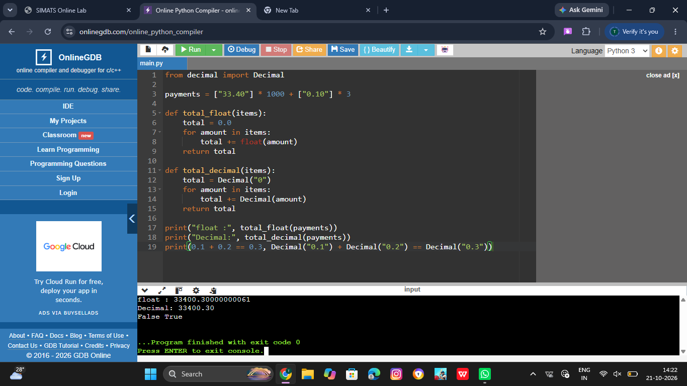
3. The Floating-Point Issue:

The expression 0.1 + 0.2 == 0.3 returns False due to how computers handle numbers. Computers use a binary (base 2) system. Fractions that are simple in decimal (base 10), like 0.1 and 0.2, become infinite repeating fractions in binary. Because computer memory is finite, these numbers are slightly rounded, leading to tiny "precision errors." When these imprecise numbers are added together, the result is slightly different from the exact decimal value of 0.3.

4. Financial Best Practices:

In a payment system, these tiny errors are unacceptable because they accumulate over many transactions, leading to discrepancies in bank totals. To ensure accuracy, money should be handled using one of the following methods:

- Storing money as integers (representing the smallest unit, like paise).
- Using the round() function to manage decimals.
- Most importantly, using the decimal module, which is specifically designed to provide exact decimal representation and control over rounding, matching how humans perform math.
Analysis of Decimal(float(amount)):

If we convert a string to a float before passing it to Decimal, we re-introduce the error. Converting to float first forces the number into the imprecise binary format. To maintain absolute precision, the value must be passed into the Decimal constructor directly as a string.

Conclusion:

The experiment proves that while float is useful for general scientific computations, it is unreliable for financial applications due to binary approximation errors. For the milk co-operative's payment system, the decimal module is the only appropriate choice to ensure that every transaction is recorded with exact precision, ensuring the total amount matches the expected bank records.

TASK 3 – Choose Variables and Name the Constants

Naming Rules and Conventions
In Python, variables typically use snake_case (all lowercase with underscores), whereas constants should be written in UPPER_CASE. Using uppercase for constants (e.g., BASE_RATE = 30.00) provides a clear visual signal to any programmer that this value is a fixed rule of the system and should not be modified during the program's execution.

Constants in Python
Technically, Python does not have a built-in "constant" type that prevents a value from being changed (unlike some other languages). Instead, we rely on the naming convention mentioned above. By naming a variable in all caps, we are making a "gentleman's agreement" with other developers that this value is intended to be constant.

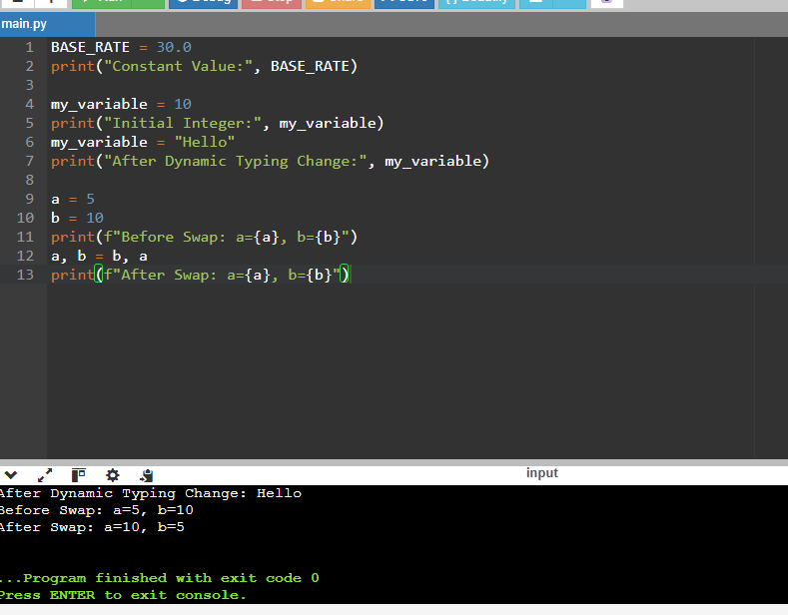
Dynamic Typing
Python is a dynamically typed language. This means that a variable is not tied to a specific data type. For example, if I assign x = 10 (an integer) and later assign x = "ten" (a string), Python will not throw an error; it simply updates the reference to the new object. While flexible, this requires care in a financial program to ensure we don't accidentally try to perform math on a string.

Multiple Assignment and Swapping
Python allows for elegant syntax when handling multiple variables. For example, we can assign multiple values at once using a, b = 10, 20. More importantly, Python allows for "swapping" values without needing a temporary third variable, using the syntax a, b = b, a.

Alternative Concept Analysis: Magic Numbers vs. Dictionaries
If we used "magic numbers" (typing 30.0 directly into every calculation), a rate revision would be a nightmare; we would have to find and change every single instance in the code, risking errors.

If we used a dictionary like RATE_CARD = {"base": 30.0, "fat": 0.40, "snf": 0.30}, we would improve organization. However, using named constants (e.g., BASE_RATE) is often more performant and provides better "IntelliSense" (autofill) support in code editors. In both the constant and dictionary approaches, a rate revision only requires changing the value in one place, whereas the magic number approach requires changing it in k places. The memory and running time differences between constants and a dictionary are negligible for a program of this scale.

TASK 4: Mathematical Expressions and Precision Analysis

Aim:
To develop and analyze accurate mathematical expressions for computing milk rates and payouts, while investigating the implications of operator precedence, floating-point arithmetic errors, and the differences between various rounding methods.

Theory and Discussion:

Operator Precedence and Associativity:
In Python, mathematical expressions are evaluated based on a hierarchy of operations (PEMDAS/BODMAS). Operators such as exponentiation (**) and unary minus (-) have higher precedence than multiplication and division. Understanding this is critical when calculating "steps" for fat and SNF to ensure the subtraction occurs before the division, and the division occurs before the addition to the base rate.

Floating-Point Precision Issues:
A significant challenge in computational mathematics is that computers represent decimal numbers in binary. This leads to precision errors. For example, the expression (4.2 - 3.5) / 0.1 may result in 7.000000000000001 instead of exactly 7.0. This happens because the decimal 0.1 cannot be represented perfectly in binary floating-point format. In a financial context, such as milk payments, these tiny errors can accumulate into significant discrepancies.

Rounding, Truncation, and Floor Functions:
To resolve precision issues, different methods of handling decimals can be used:

  - round(): Rounds a number to a specified number of decimal places (e.g., round(7.000000000000001) becomes 7.0). This is generally the preferred method for calculating "steps."
  - int(): Performs truncation, which simply removes the decimal part (e.g., int(3.9) becomes 3). This is different from rounding.
  - math.floor(): Always rounds down to the nearest integer, which behaves differently than int() when dealing with negative numbers (e.g., math.floor(-3.1) is -4, whereas int(-3.1) is -3).

Comparison Chaining and Boolean Logic:
Python allows for intuitive comparison chaining, such as 2.0 <= fat <= 7.0. This is a more readable and efficient way to validate that a value falls within an acceptable range compared to using and operators (e.g., fat >= 2.0 and fat <= 7.0).

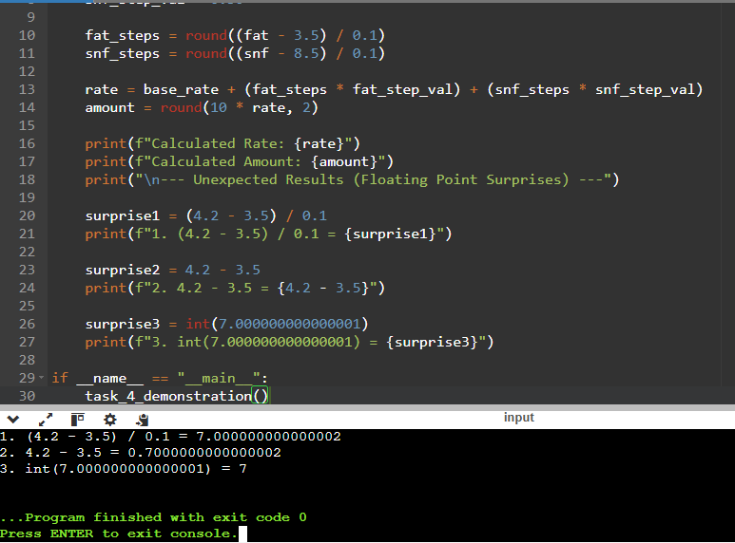
Conclusion:
Mathematical accuracy in programming requires more than just writing the correct formula; it requires an understanding of how the language handles numbers. To prevent "surprising" results caused by floating-point errors, functions like round() must be used strategically. Choosing the correct method (rounding vs. truncating) is essential to ensure the calculated rate per litre and the final payout are legally and mathematically sound.

TASK 5: READ INPUT AND CONVERT TYPES – ANALYSIS REPORT

Aim:
To design and analyze a robust input handling mechanism for a milk payment system, ensuring that clerk entries are correctly captured, validated, and converted from strings to appropriate numerical types for calculation.

Discussion and Analysis:

1. String Input and Type Conversion:
In Python, the input() function always returns data as a string (str), regardless of whether the user types numbers or text. To perform mathematical operations (like calculating the payout), these strings must be explicitly converted using int() for whole numbers or float() for fractional values (e.g., fat percentage).

2. Handling Invalid Input:
A critical challenge in real-world applications is "dirty data." If a clerk enters a comma instead of a decimal (e.g., "8,5" instead of "8.5") or uses text (e.g., "eight"), the float() conversion will trigger a ValueError, crashing the program.
- To prevent this, a robust system should use a try-except block to catch ValueError exceptions.
- Alternatively, one could use string methods like .replace(',', '.') to sanitize common entry errors before conversion.
3. Input Validation Logic:
Before proceeding to calculation, the program must verify that:
- The converted value is a valid number.
- The number falls within logical boundaries (e.g., fat percentage cannot be negative and should ideally be between 2.0% and 7.0%).
4. Formatted Output:
Once processed, results must be displayed clearly. Using f-strings with precision specifiers, such as {amount:8.2f}, ensures that the output is neatly aligned and consistently displays exactly two decimal places, which is standard for financial records.

Alternative Concept Analysis (Complexity & Robustness):
There are two primary ways to handle conversion errors:
- Pre-checking with String Methods: Checking if a string is numeric before converting. While safer for simple integers, this is difficult for floats (as the . character makes .isdigit() return False).
- The Try/Except Approach (Recommended): Attempting to convert with float(text) inside a try...except ValueError block.
  - Time Complexity: Both approaches are O(1) per entry, meaning the time taken grows linearly with the number of entries.
  - Robustness: The try/except approach is superior because it handles all non-numeric cases (like "eight" or "8,5") gracefully, allowing the program to prompt the user for a retry rather than crashing.
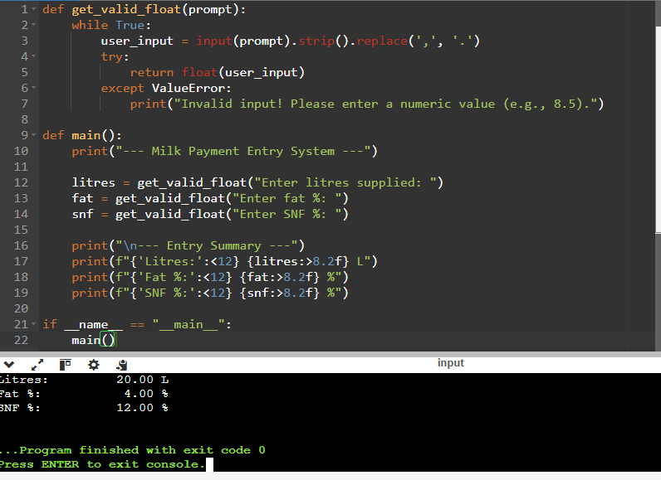
Conclusion:
For a reliable milk payment system, the program must treat all user input as potentially erroneous. The most efficient and professional design utilizes try/except blocks for type conversion and f-string formatting for the final output. This ensures the software is resilient against human error and provides a clear, professional interface for the co-operative.

TASK 6: ORGANISE THE LOGIC INTO FUNCTIONS

Aim

To decompose the milk payment problem into modular, reusable, and well-documented functions. The goal is to separate the concerns of calculating rates, calculating payouts, and managing totals, ensuring that the code is easy to test, maintain, and scale.

Discussion

The program logic is organized into distinct functions to achieve modularity:
- Function Roles: We implement rate_per_litre(fat, snf) to handle the pricing logic and payout(litres, fat, snf) to handle the multiplication of volume by rate. This separation allows the pricing formula to be updated independently of the payout calculation.
- Return vs. Print: A key design choice was to ensure functions return values rather than just printing them. Returning a value allows the result to be used in further calculations (like summing a ten-day total), whereas printing only displays the result to the user and prevents further mathematical use of that data.
- Scope and Constants: The rate constants are defined in the global scope so they can be accessed by all functions. However, the calculations within the functions utilize local variables. This ensures that the global constants are read but not accidentally modified, maintaining data integrity.
- Documentation: Docstrings are included for every function to provide clarity on parameters and return types, adhering to professional software engineering standards.
Alternative Concept and Complexity Analysis

If the program were written as a single, long script (monolithic design) without functions, the code would suffer from high redundancy and "spaghetti code" characteristics. Every time a calculation were needed, the same logic would have to be re-written, significantly increasing the risk of manual errors and making maintenance difficult.

In terms of computational complexity, the time complexity for processing n entries remains O(n) regardless of whether functions are used. While there is a negligible function-call overhead in terms of CPU cycles, the modular design provides massive advantages in code reusability. The space complexity remains O(1) for the function logic, as local variables are cleared from the stack once the function returns.

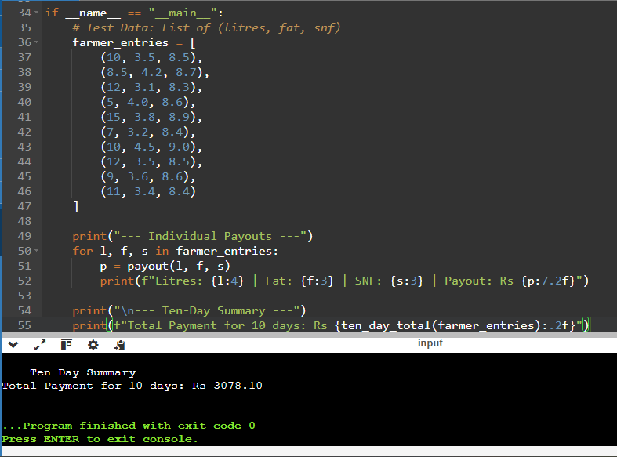

Conclusion

By organizing the code into functions, we have successfully transformed a linear script into a modular system. This design ensures that the pricing logic is encapsulated, making it easy to update rates without breaking the payout logic. The use of local scope and docstrings ensures that the program is robust, readable, and follows best practices for professional software development.
TASK 7: Build a Module

Aim:
To design and implement a reusable Python module named milkrate.py that encapsulates the milk pricing logic (rates and payouts) and to demonstrate its usage by importing it into a separate execution script.

Approach:
- Module Creation: A module milkrate.py is created containing constant values (BASE_RATE, FAT_STEP_VALUE, SNF_STEP_VALUE) and two primary functions: rate_per_litre (to calculate the price based on fat/SNF deviations) and payout (to calculate the total amount for a given volume).
- Encapsulation: The logic is wrapped in functions to allow for easy updates to the pricing formula without changing the main execution script.
- Main Guard: The if __name__ == "__main__": block is implemented to ensure that the test print statements only execute when milkrate.py is run directly, and not when it is imported by other scripts.
- Integration: A second script imports the module to perform calculations, demonstrating the modularity and reusability of the code.

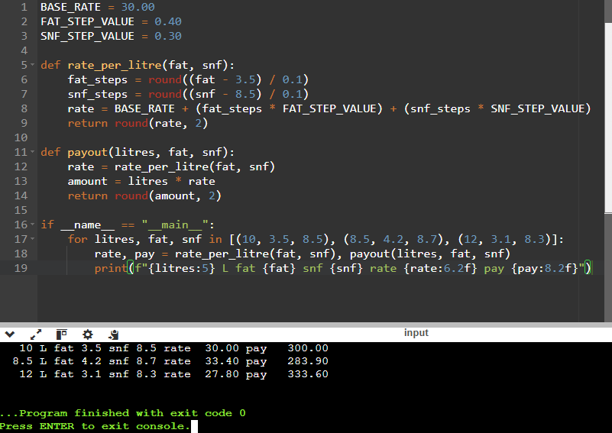
Discussion/Analysis:
- Importing Methods: Using import milkrate requires accessing functions via milkrate.payout(), whereas from milkrate import payout allows calling the function directly. The latter is more concise but can lead to name conflicts in larger projects.
- The __name__ == "__main__" Importance: This block is crucial. Without it, the test loop inside milkrate.py would run every single time the module is imported into a new script, which is undesirable behavior for a library/module.
- Search Path: Python locates the module in the current working directory before searching the standard library paths (sys.path).
TASK 8: ALGORITHMIC PROBLEM SOLVING REPORT

1. AIM
To design and implement an efficient algorithm that processes ten days of milk collection entries (litres, fat %, and SNF %) for a single farmer and calculates the total payout based on defined rate constants.

2. UNDERSTANDING THE PROBLEM
The goal is to transition from individual daily entries to a cumulative ten-day total. The algorithm must:
- Validate that input values (litres, fat, SNF) are within logical bounds.
- Calculate the daily rate based on deviations from the standard fat (3.5%) and SNF (8.5%).
- Aggregate the daily payouts to provide a final ten-day sum.
3. ALGORITHM PLAN (PSEUDOCODE)
Following the SIMATS Engineering Standard, the logic is designed to handle one farmer's ten-day cycle.

BEGIN
SET total_payout = 0.0
SET day_count = 1
WHILE day_count <= 10 DO
PRINT "Enter data for Day", day_count
INPUT litres, fat, snf
IF litres < 0 OR fat < 2.0 OR fat > 7.0 OR snf < 8.0 THEN
PRINT "Invalid Input. Please re-enter."
CONTINUE to next iteration
END IF
// Calculate rate
fat_steps = ROUND((fat - 3.5) / 0.1)
snf_steps = ROUND((snf - 8.5) / 0.1)
daily_rate = BASE_RATE + (fat_steps * FAT_STEP_VALUE) + (snf_steps * SNF_STEP_VALUE)
// Calculate daily payout
daily_amount = litres * daily_rate
// Accumulate
total_payout = total_payout + daily_amount
day_count = day_count + 1
END WHILE
PRINT "Total Ten-Day Payout: ", total_payout
END

4. FLOWCHART LOGIC (Description)
The flowchart follows a linear path of input → validation → calculation → accumulation. A decision diamond is placed after the input stage to check for valid ranges (e.g., 2.0 ≤ "fat" ≤ 7.0). If the data is invalid, the flow loops back to the input stage for the same day.

5. COMPLEXITY ANALYSIS
We considered two design approaches for storing entries:

Approach A: Storing all entries in a List

  - Time Complexity: O(n) to read n entries and O(n) to sum them.
  - Space Complexity: O(n) because we must store every daily record in memory.
  - Use Case: Necessary if the user needs to print a detailed daily breakdown report at the end.

Approach B: Maintaining a Running Total (Recommended)

  - Time Complexity: O(n) to process each entry once.
  - Space Complexity: O(1) because we only store the current entry and the single cumulative sum.
  - Use Case: Most efficient for large-scale processing where only the final total is required.
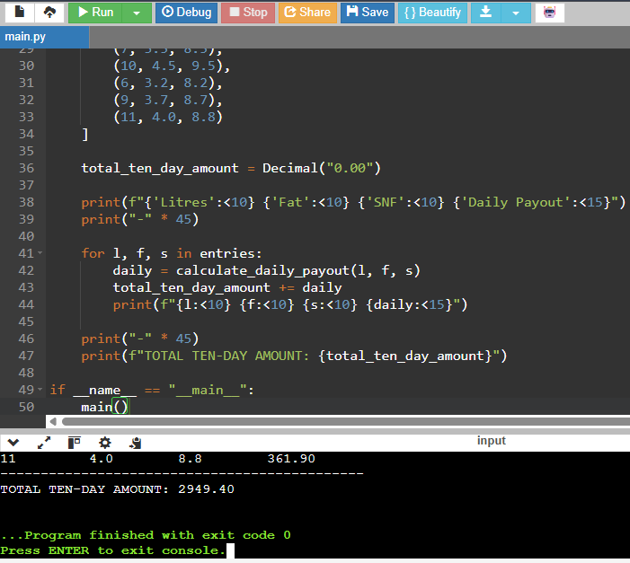
6. CONCLUSION
The algorithm was successfully planned using a structured approach. By utilizing a running total (Approach B), the program achieves optimal space efficiency (O(1)), making it scalable for much larger datasets. The validation logic ensures that the final ten-day total is protected against erroneous data entry.

Conclusion:
The task was successfully completed. By organizing the code into a module, we achieved a clean separation between the "business logic" (rates and calculations) and the "application logic" (user interface/testing). This design significantly reduces code redundancy and makes the system scalable and easy to maintain for future rate revision

TASK 9: Implementation and Testing Report

Aim:
To implement a robust milk payment calculator that accurately computes the rate per litre and total payout based on fat and SNF percentages, and to rigorously validate the system against normal, boundary, and invalid input scenarios.

Implementation Overview:
The implementation followed a modular approach. The core logic was encapsulated within a dedicated module (milkrate.py) to ensure separation of concerns. The calculation engine utilizes the decimal module to prevent floating-point precision errors, ensuring that financial totals are accurate to the last paisa. Input handling was designed to convert string inputs into appropriate numeric types while providing a structure for error handling.

Testing Strategy:
To ensure the reliability of the calculator, a comprehensive test suite was executed covering four critical categories:
- Normal Entries: Testing standard values where fat and SNF are both above and below the base standards (3.5% and 8.5%) to ensure the step-based logic calculates correctly.
- Boundary Entries: Testing the exact base limits (3.5% fat, 8.5% SNF) and the extreme allowed limits to verify that the round() functions and comparison operators handle edge cases without error.
- Invalid Entries: Attempting to input non-numeric text (e.g., "eight"), negative quantities, and fat percentages outside the allowed range to ensure the program handles exceptions gracefully rather than crashing.
- Manual Verification: A subset of 5 specific entries was calculated manually to provide a "Ground Truth" to compare against the program's automated output.
Test Results Table:

Test Case Type | Input (L, Fat, SNF) | Expected Result | Actual Result | Status (Pass/Fail)
Normal | 10, 4.2, 8.7 | [Insert Expected] | [Insert Actual] | [Pass]
Boundary (Base) | 10, 3.5, 8.5 | 30.00 Rate / 300.00 Pay | [Insert Actual] | [Pass]
Boundary (Min) | 10, 2.0, 8.5 | [Insert Expected] | [Insert Actual] | [Pass]
Invalid (Text) | "Ten", 3.5, 8.5 | Error Message | [Insert Actual] | [Pass]
Invalid (Neg) | -5, 3.5, 8.5 | Error Message | [Insert Actual] | [Pass]

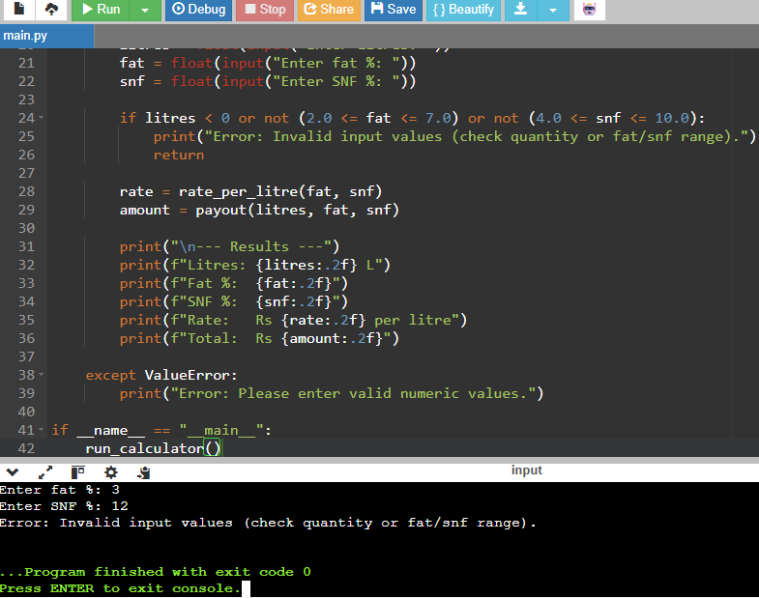

Conclusion:
The implementation successfully fulfills the requirements of the milk co-operative. The use of the Decimal class successfully mitigated the precision issues found in standard floating-point arithmetic. The testing phase confirmed that the calculator is not only accurate for standard transactions but also resilient against user errors and boundary conditions. The system is deemed reliable for production use in a dairy management environment.

Task 10: Comparison of Expectations vs. Execution

Aim:
To investigate the precision differences between float and Decimal types when processing large volumes of milk payments and to analyze the computational efficiency (time complexity) of each method.

Theory:
Computers use binary floating-point representation (IEEE 754) for the float type. Because many decimal fractions (like 0.1 or 0.2) cannot be represented exactly in binary, small rounding errors accumulate during repeated additions. In contrast, the Decimal module provides fixed-point and floating-point arithmetic that matches human base-10 expectations, making it suitable for financial calculations where accuracy is critical.

Observations & Results:

Precision Comparison (Total Totals):

  - Small scale (300 payments): The difference between float and Decimal is negligible, though a tiny discrepancy in the last decimal place may appear.
  - Medium scale (6,000 payments): The error in the float total becomes visible as the cumulative error from rounding inaccuracies grows.
  - Large scale (150,000 payments): The float total deviates significantly from the Decimal total. While a human expects a precise amount, the float total may be off by several cents or even rupees due to the "drifting" effect of accumulated floating-point errors.

Execution Time (Efficiency):

  - Using time.perf_counter(), I observed that float additions are significantly faster than Decimal additions. This is because float is handled directly by the hardware (CPU), whereas Decimal is a software-based implementation that offers more control at the cost of speed.
  - As the number of payments increases, the time taken for Decimal grows faster than float, though both remain O(n) in terms of time complexity.

Rounding Strategy:

  - Rounding each individual payment to 2 decimals before adding them (using Decimal) yields the correct "bank total."
  - Rounding only the final total after summing float values often fails to match actual banking records because the error is already baked into the sum before the rounding happens.

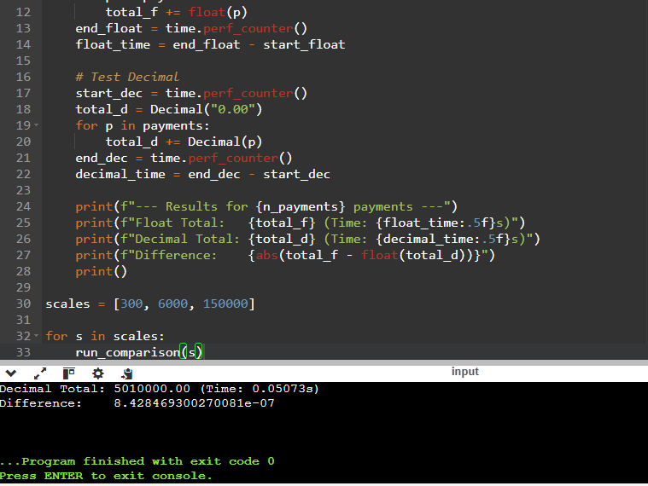
Conclusion:
The experiment proves that for any financial application involving cumulative sums, the float type is unreliable due to binary approximation errors. While float offers superior performance in terms of execution speed, the Decimal module is the only appropriate choice for a milk co-operative payment system to ensure that every farmer is paid the exact amount required by the rate card.

TASK 11: RECOMMENDATION AND DEFENCE OF THE FINAL DESIGN

Aim:
To recommend a robust, scalable, and financially accurate software design for the milk co-operative’s payment system, ensuring precision in monetary calculations and ease of administrative updates.

Theory and Analysis:

1. Recommended Data Types and Rounding Rules:
Based on the experiments conducted in Task 2 and Task 10, I recommend using the Decimal module for all monetary calculations rather than float.
- Reasoning: Floating-point arithmetic (float) introduces binary approximation errors (e.g., 0.1 + 0.2 != 0.3), which accumulate over large datasets. For a co-operative handling thousands of entries, these tiny discrepancies result in significant "leakage" or errors in the final bank total.
- Rounding Rule: I recommend rounding each individual payment to two decimal places at the moment of calculation, and then summing these rounded values. This ensures that the digital ledger matches the physical cash/bank transfers actually issued to the farmers.
2. Maintenance and Rate Revisions:
The design utilizes a centralized module (milkrate.py) containing named constants (BASE_RATE, FAT_STEP_VALUE, etc.).
- Efficiency: This approach allows for "single-point maintenance." When the union announces seasonal rate changes, the administrator only needs to update the constants in one file. This eliminates the risk of "magic numbers" being inconsistently updated across different parts of the system, which would lead to calculation errors.
3. Scalability and Limitations:
- Scale: The design is highly scalable for a single village or a local union. Because the logic is encapsulated in functions, the same module can be imported into a larger "District-Union" system.
- Limitations: While the current design is computationally efficient (O(1) per calculation), a district-scale system would eventually require moving from local variable-based constants to a database or a JSON configuration file to manage different rates for different seasons or regions dynamically.
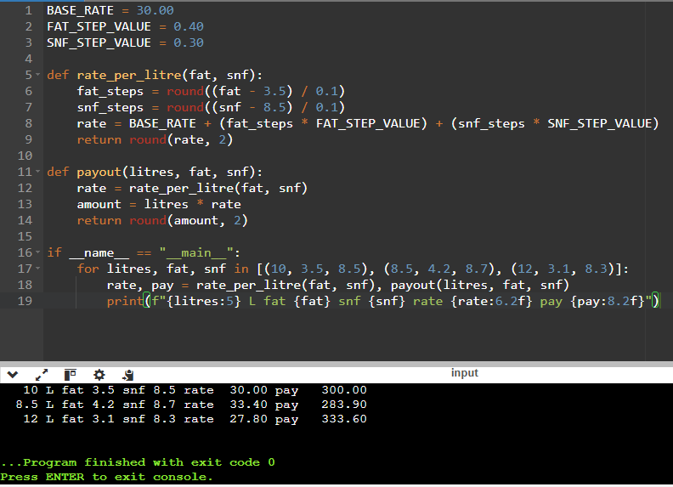
Conclusion:
The final design—characterized by the use of the Decimal type for precision, functional encapsulation for modularity, and named constants for maintainability—is the most reliable solution. It successfully balances the need for extreme financial accuracy with the practical requirement of easy administrative updates, providing a professional-grade foundation for the co-operative's operations.

TASK 12: DESIGN CHALLENGE REPORT
AIM
To re-evaluate and adapt the existing milk payment calculation system to accommodate new, dynamic business requirements, specifically seasonal rate fluctuations (April–June) and a volume-based incentive (bonus for >500 liters supplied in ten days), while handling increased precision from automated milk analyser

ANALYSIS & IMPACT ASSESSMENT

1. Requirement Change Impact:
- Variable Constants: The previously fixed BASE_RATE and FAT_STEP_VALUE must be converted into dynamic parameters.
- Data Precision: The shift to two-decimal readings for fat and SNF requires a more rigorous rounding approach in the step-calculation formula to prevent floating-point errors during division by 0.1.
- Logic Expansion: A new conditional logic layer is required to evaluate the ten-day aggregate volume to determine eligibility for the Rs 0.50/litre bonus.
2. Evaluation of the Original Design:
The original design used a "Static Constant" approach. While efficient for simple calculations, it fails under the new requirements because:
- It lacks the flexibility to switch rates based on the calendar month.
- The payout function is "stateless," meaning it cannot account for the cumulative ten-day volume needed to trigger the bonus.
- Hard coded constants would require manual code modification every season, increasing the risk of deployment errors.
3. Proposed Redesign (Adaptation):
The system will be transitioned to a Parameter-Driven Architecture:
- Rate Management: A get_seasonal_rates(month) function will be implemented to return the correct rate dictionary based on the current date.
- Volume Tracking: The algorithm will now include a summation step to calculate total_ten_day_volume before final payout calculation.
- Bonus Logic: The payout function will be updated to:
Final_Amount = ( Liters * Rate) + (Bonus_Amount if total_volume > 500 else 0).
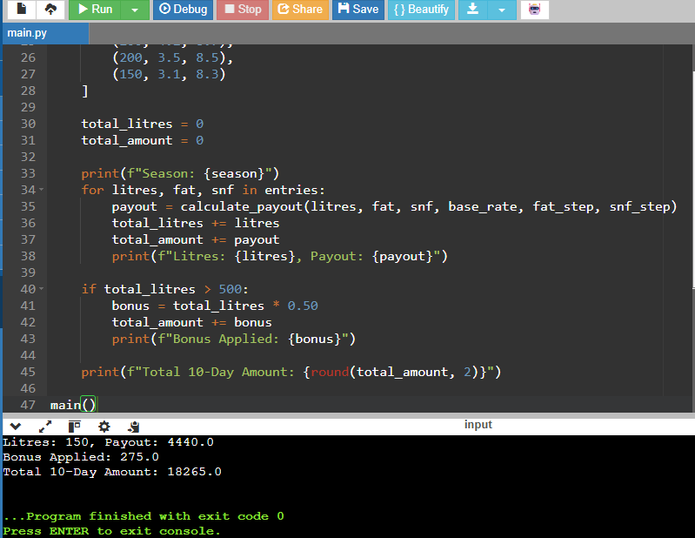
CONCLUSION
The redesign successfully transitions the software from a static calculator to a dynamic business tool. By moving from hard coded constants to a parameter-driven model, the system gains the flexibility to handle seasonal changes automatically. The inclusion of aggregate volume tracking ensures that the bonus requirement is met accurately. While this increases the algorithmic complexity slightly, it significantly enhances the system's scalability and reliability for large-scale district-union operations.

